AAW

AWS ADVANCED ASSIGNMENT-2

DAY 5-6

ARAVIND G KUMAR

**Project 1: Working with IAM Roles with S3 and bootstrapping with EC2**

Task 1: Creating a bootstrapped instance

* Create a Linux instance

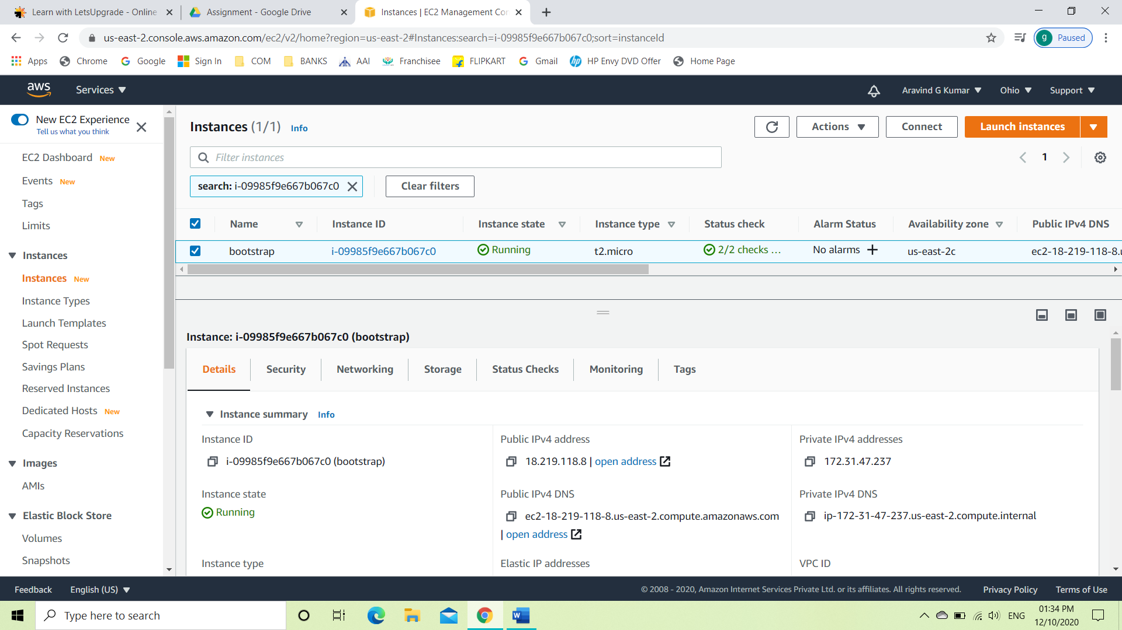

* Edit the user data with the following code

#!/bin/bash

yum -y install httpd

service httpd start

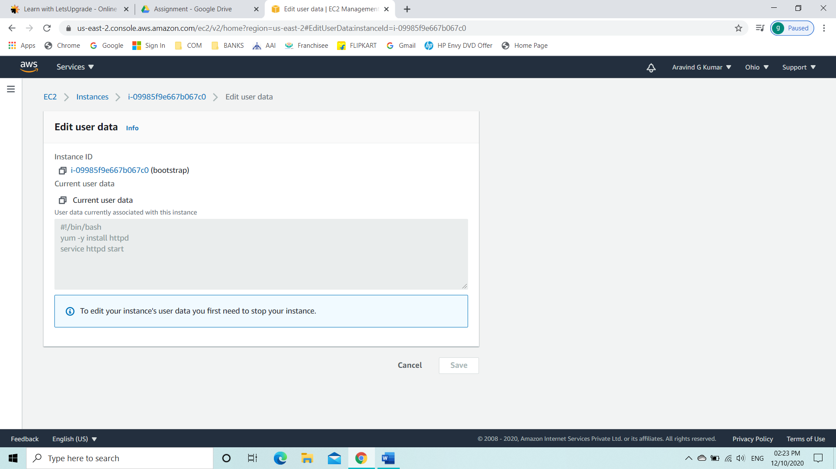

* Launch it using the Public IPv4

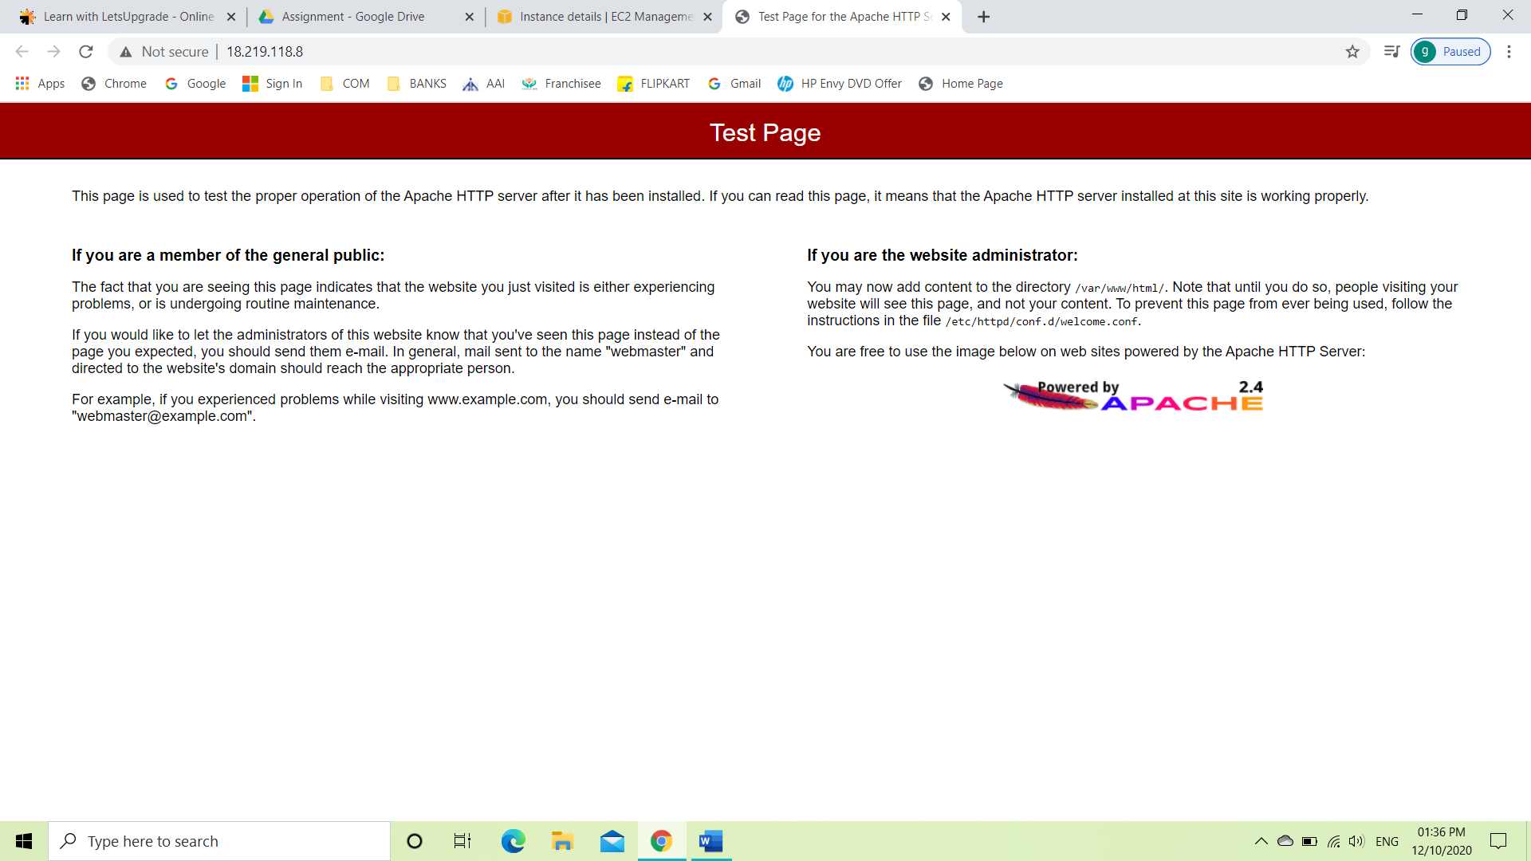

Task 2: Checking bucket list and creating a new bucket from EC2 using IAM Roles

* Create an IAM role

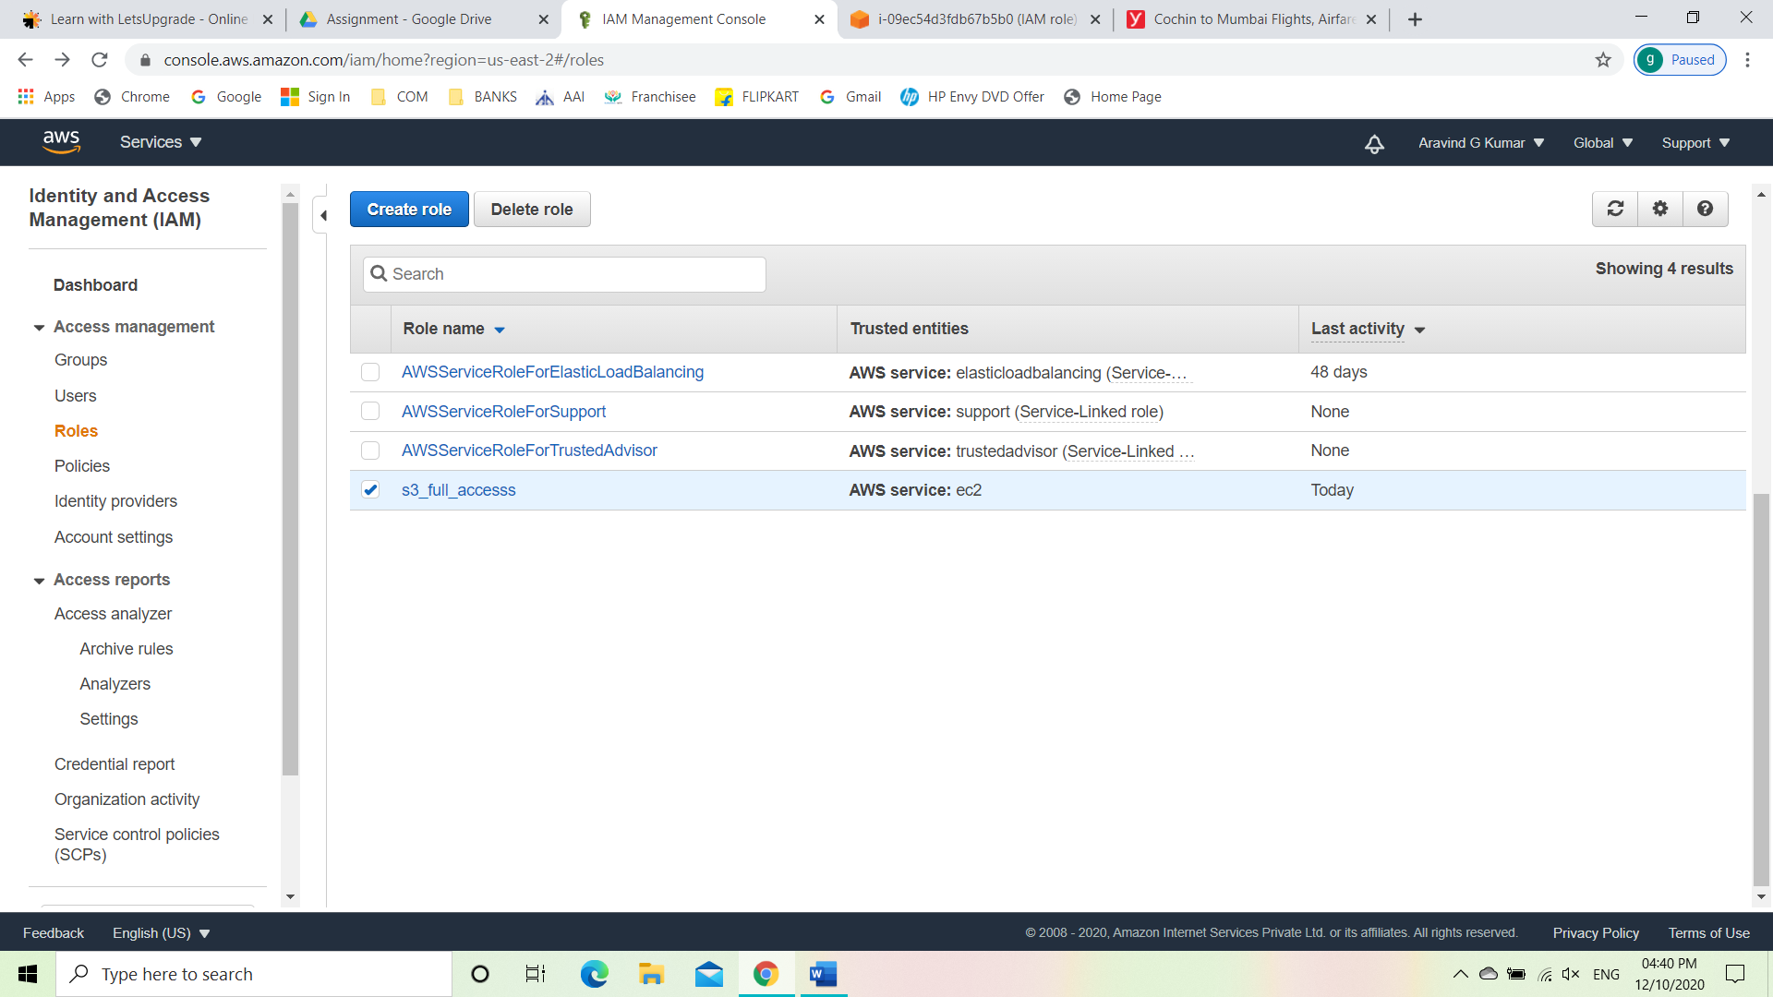

* Create a Linux instance with the IAM role assigned

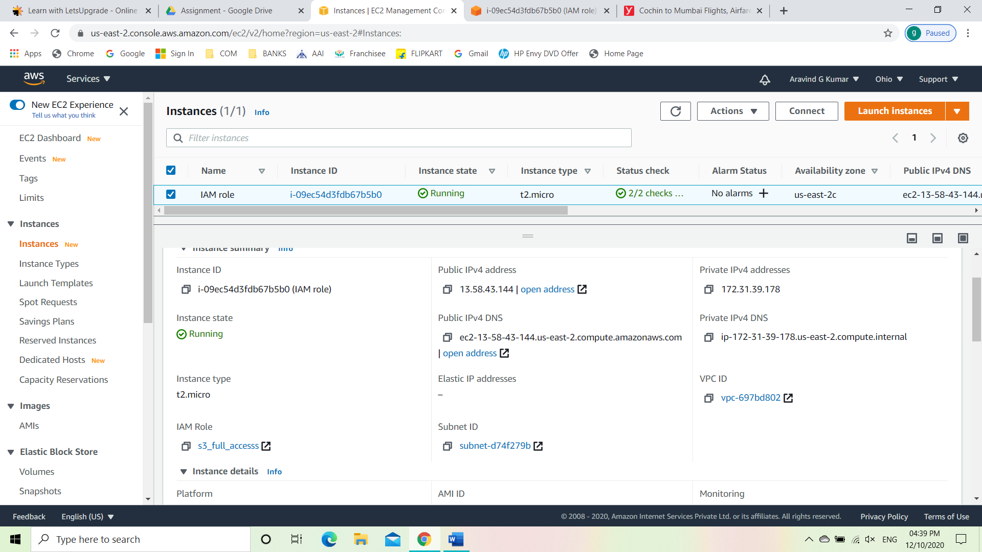

* Connect using Ec2 instance connect

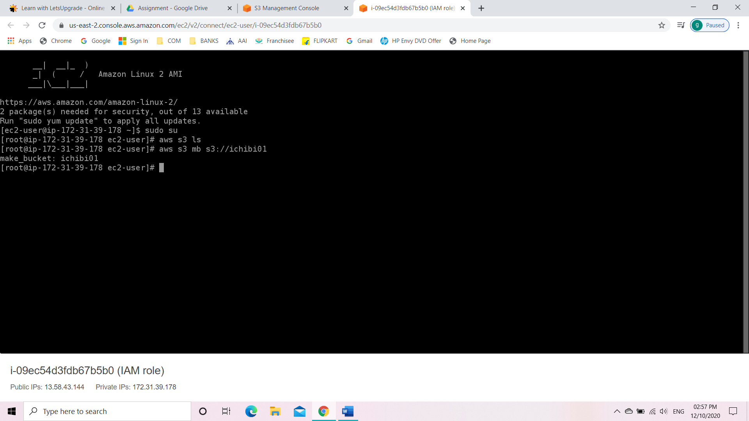

* Created bucket using the codes

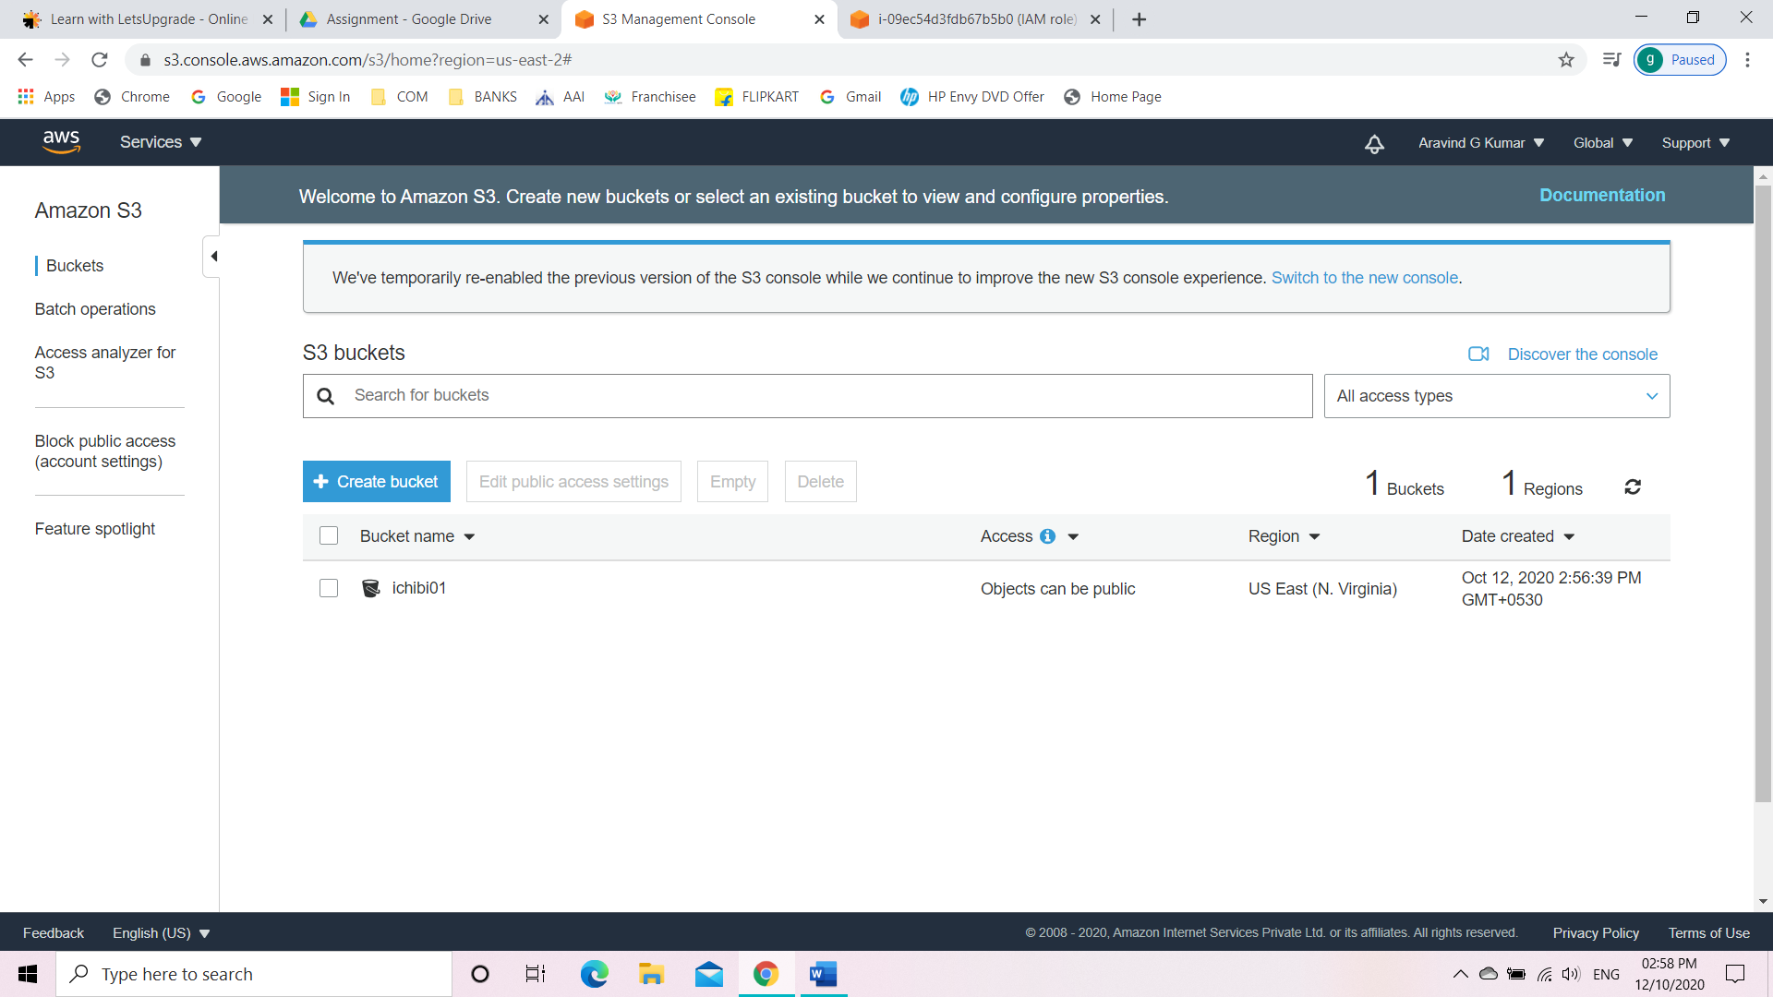

Task 3: Hosting a webpage using the bootstrap script on ec2.

* Create an IAM role for s3 full access
* Create a bucket with an object with .html extension

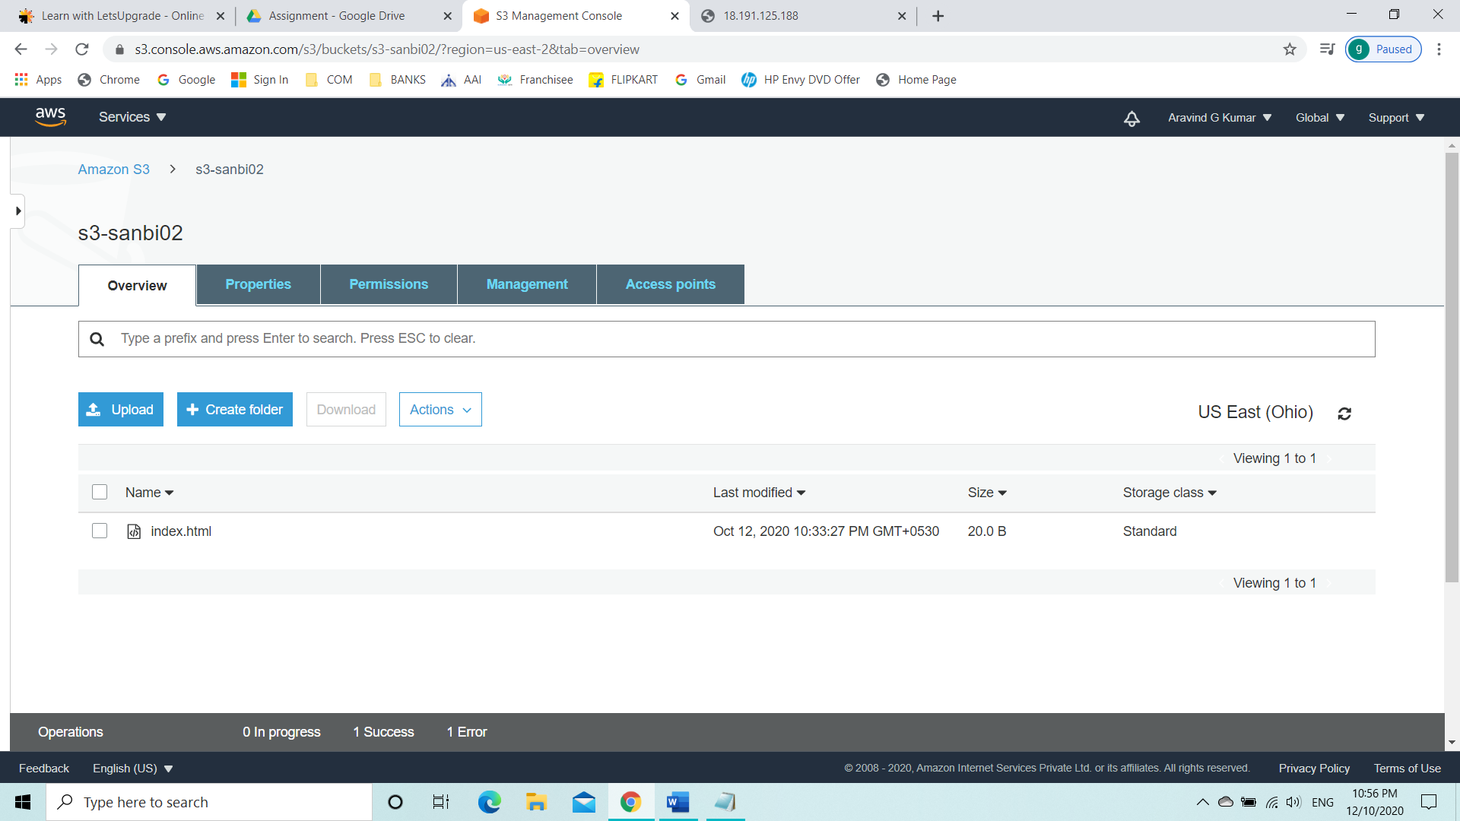

* Create a Linux instance with the IAM role attached and add user data.

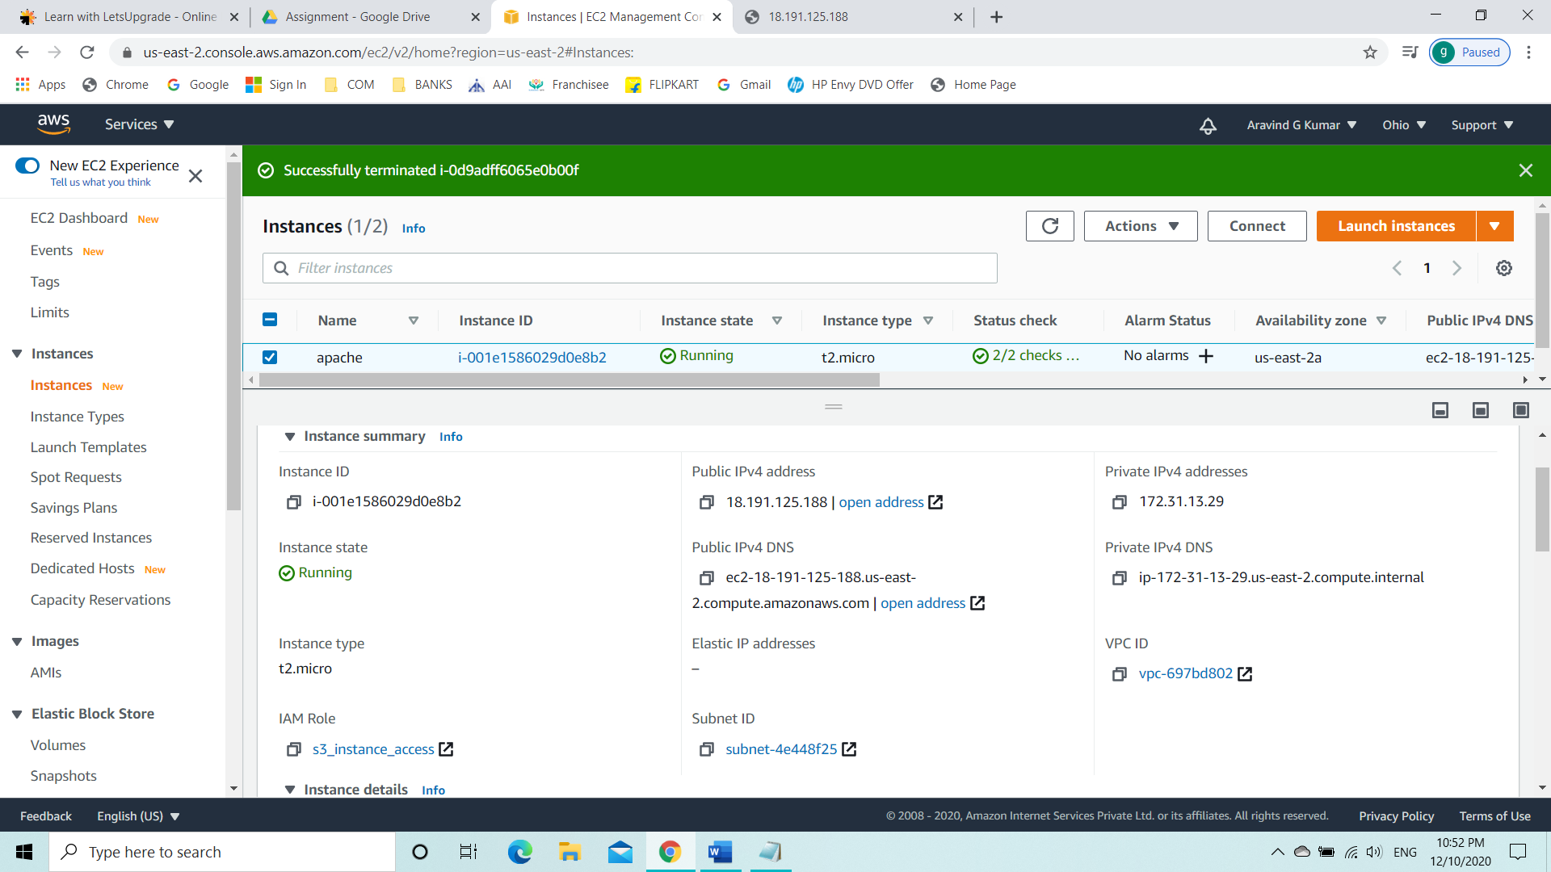

* Showing the user data which, we created.

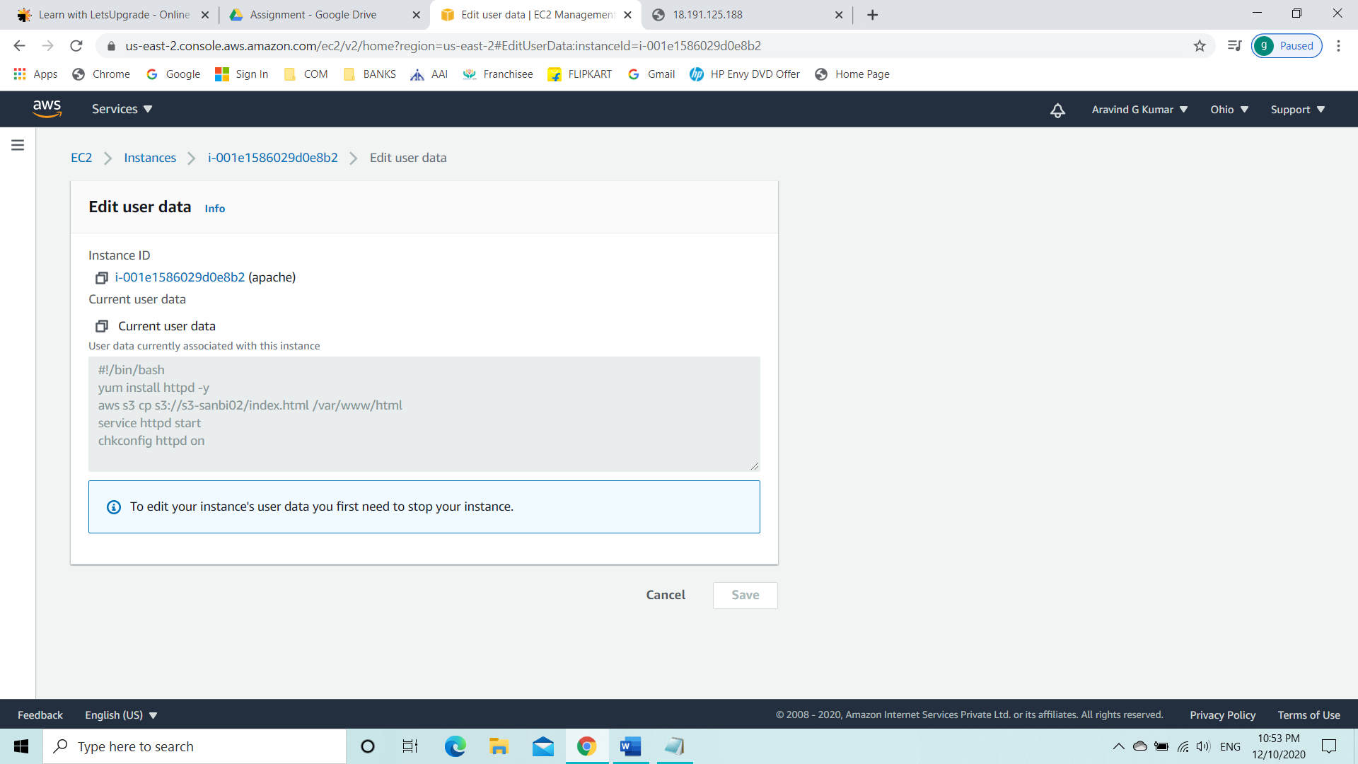

* Connecting the instance and launching it using the Public IPv4.

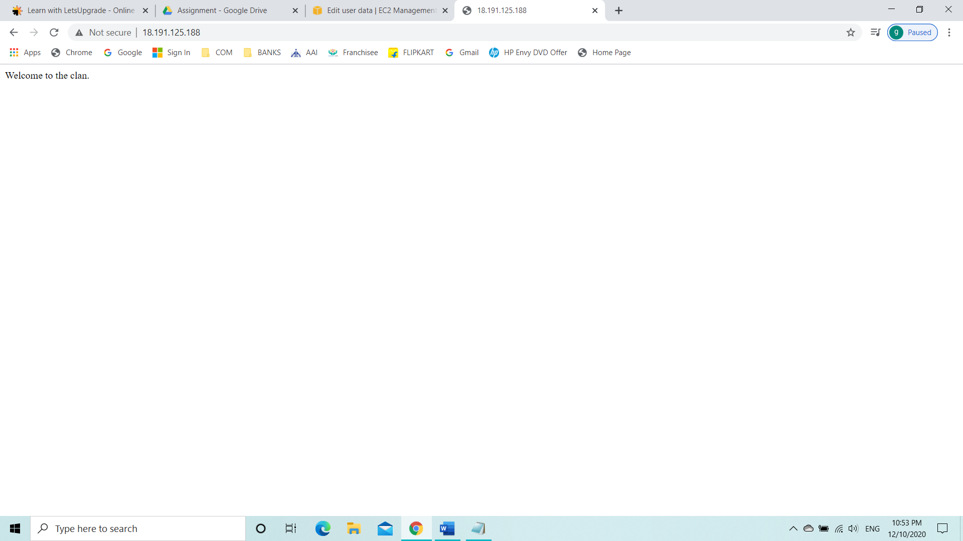

**Project 2: Creating an EC2 instance in custom VPC**

Task 1: Create a VPC

* Go to VPC from service tab
* Select your VPC
* Create VPC

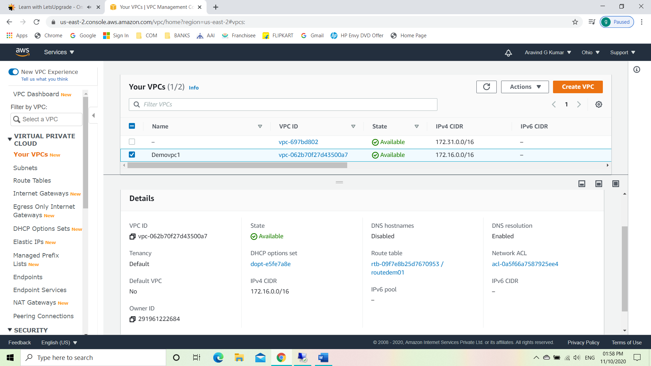

Task 2: Create an Internet gateway.

* Select internet gateway.
* Create internet gateway.
* Attach the internet gateway to the created VPC.

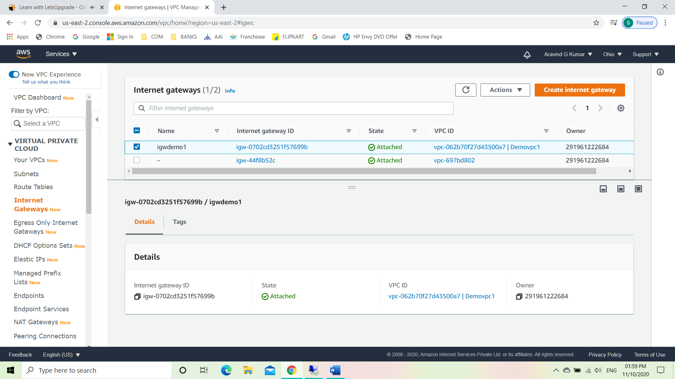

Task 3: Create a route table

* Select route table
* Create route table
* Click on edit routes
* Add route like 0.0.0.0/0
* Select set main route table

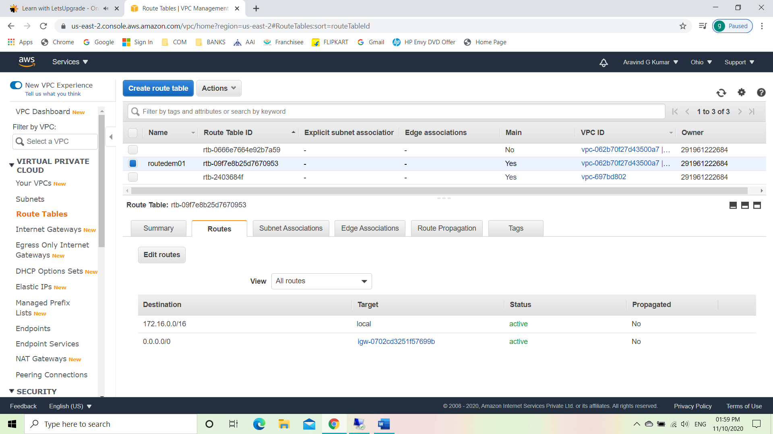

Task 4: Create a subnet

* Select subnet
* Create subnet
* Edit IPv4 CIDR block to 172.16.0.0/24
* Modify auto assign
* Enable auto assign IPv4

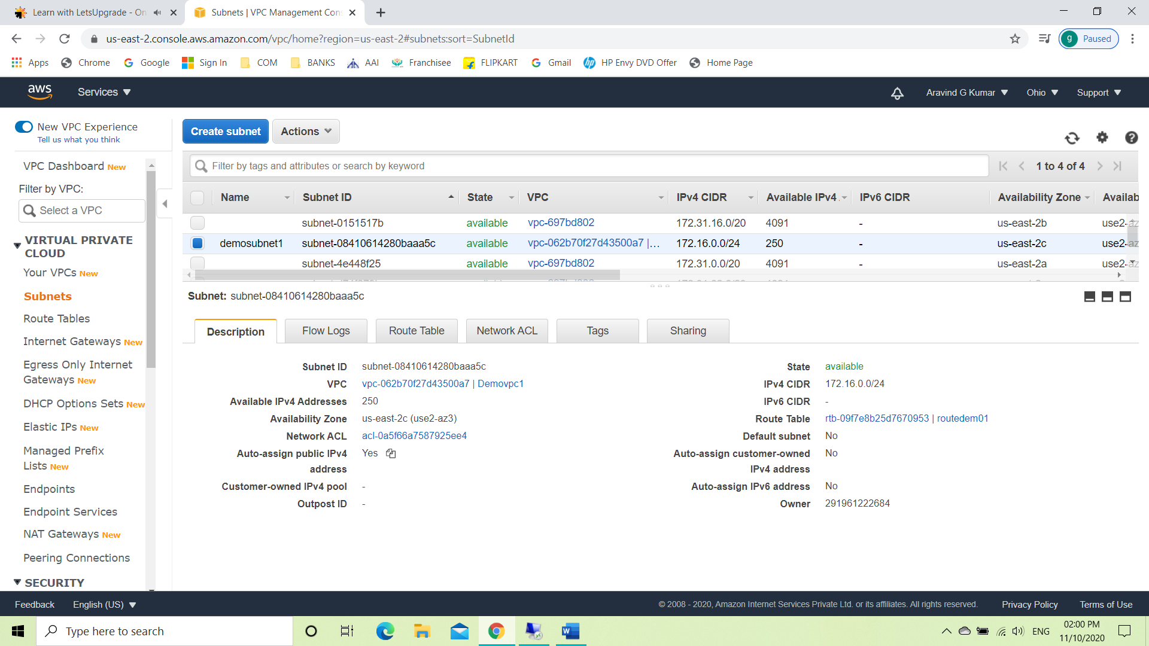

Task 5: Create an EC2 in custom vpc.

* Create a windows instance
* Add the created VPC

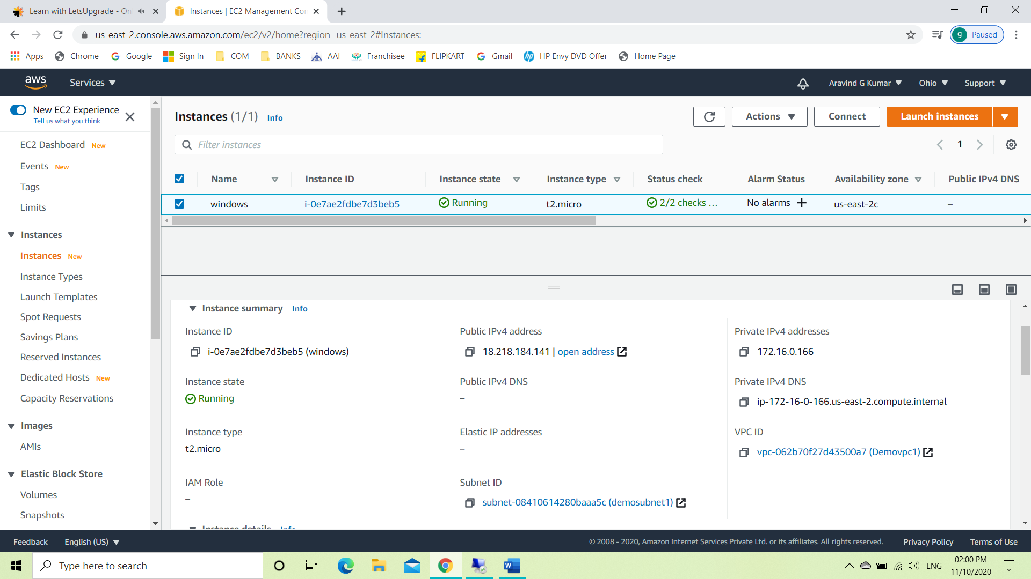

Task 6: Check ipconfig in VM command prompt.

